LUNG CANCER RISK FACTORS AND SURVIVAL OUTCOME

BY
OKE MOYINOLUWA

Outline
- Introduction………………………………………………………………….….3
- Problem Statement / Project Objective………………………………….…...4
- Dataset Description……………………………………………………….……5
- Dataset Source…………………………………………………………….……6
- Data Cleaning and Preparation……………………………………………….7
- Data Analysis……………………………………………………………………8-11
- Dashboard Development……………………………………………………...12-13
- Key Findings/Insights………………………………………………………….14
- Recommendations…………………………………………………………….15
- Conclusion……………………………………………………………….…….16

1. Introduction
Lung cancer is a major health concern, and understanding the factors associated with lung cancer outcomes can provide useful insights into patient characteristics, risk factors, diagnosis, and survival. Data analysis can help identify patterns within patient records and present these findings in a clear and meaningful way.
This project analyzes a lung cancer risk factor and survival dataset containing 2,000 patient records covering the period from 2015 to 2026. The analysis focuses on patient demographics, cancer types, risk factors, cancer stages, smoking status, and survival outcomes.
Microsoft Excel was used to clean and prepare the dataset, perform the analysis, create PivotTables and charts, and develop an interactive dashboard. The findings from the analysis are used to identify important patterns and provide data-driven recommendations.

2. Problem Statement / Project Objective

2.1 Problem Statement
The dataset contains information on lung cancer patients, including demographic characteristics, risk factors, cancer type, cancer stage, smoking status, and survival outcomes. However, raw patient data can be difficult to interpret without proper analysis.
This project therefore aims to analyze the dataset to identify patterns in cancer types, survival outcomes, risk factors, and diagnosis trends, and present the findings in a clear and interactive Excel dashboard.

2.2 Project Objectives
The objectives of this project are to:
- Clean and prepare the lung cancer dataset for analysis.
- Analyze the distribution of cancer types among the patients.
- Examine overall survival outcomes and survival rates.
- Investigate survival patterns across different cancer stages.
- Examine the relationship between smoking status and survival outcomes.
- Compare survival outcomes by gender.
- Analyze the number of recorded patients by diagnosis year from 2015–2026.
- Develop an interactive Excel dashboard to communicate the key findings clearly.

3. Dataset Description
The dataset used for this project is a Lung Cancer Risk Factor and Survival Dataset containing 2,000 patient records and 46 variables.
The dataset contains information covering the period 2015–2026 and includes several categories of patient information:
- Demographics: Age, age group, gender, country, and WHO region.
- Smoking and lifestyle factors: Smoking status, cigarettes per day, years of smoking, pack-years, alcohol use, BMI, and exercise frequency.
- Environmental and medical risk factors: Secondhand smoke, family history, occupational hazards, air pollution exposure, asbestos exposure, radon exposure, and previous cancer history.
- Symptoms: Coughing, shortness of breath, chest pain, coughing up blood, fatigue, weight loss, wheezing, and other symptoms.
- Cancer information: Cancer type, NSCLC subtype, cancer stage, tumor size, metastasis, and diagnosis method.
- Treatment and survival: Treatment, survival months, and survival status.

4. Dataset Source
The dataset was sourced from Kaggle, an online platform that provides datasets and resources for data science and analytics projects.
The Lung Cancer Risk Factor and Survival Dataset was selected to expand my experience across different data analytics domains. Most of my previous projects focused mainly on business and sales-related datasets, so I wanted to challenge myself by working with data from the healthcare domain.
I chose the Lung Cancer Risk Factor and Survival Dataset because it contains a wide range of patient-related information, including demographic characteristics, smoking and lifestyle factors, environmental and medical risk factors, cancer types, cancer stages, treatment, and survival outcomes. These variables provided an opportunity to investigate meaningful patterns in lung cancer characteristics and survival outcomes.
The dataset was also suitable for demonstrating the practical application of the data analytics skills I had developed, including data cleaning, data preparation, PivotTable analysis, calculations, data visualization, KPI development, and interactive dashboard creation using Microsoft Excel.
Overall, selecting this dataset allowed me to step outside my previous business-focused projects, apply my analytical skills to a healthcare-related dataset, and gain experience analyzing data from a different real-world domain.
5. Data Cleaning and Preparation
The dataset was cleaned and prepared in Microsoft Excel before conducting the analysis. The purpose of the cleaning process was to ensure that the data was accurate, consistent, complete, and suitable for analysis.
The following steps were carried out:

Duplicate Check
The patient_Id column was checked for duplicate records. No duplicate patient records were identified, so all 2,000 patient records were retained.
Figure 1
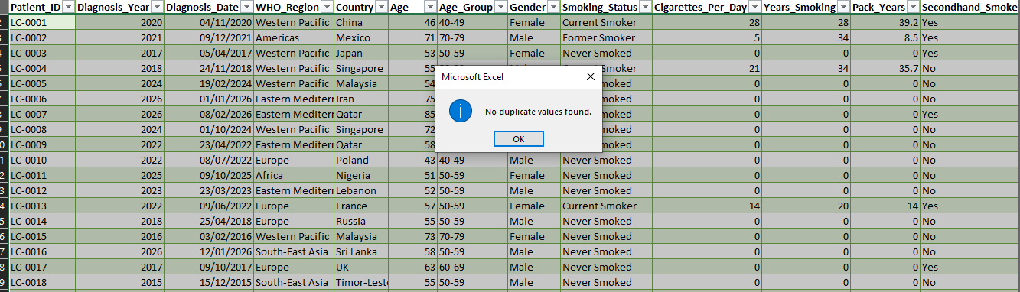

Missing Values Check
The dataset was checked for missing or blank values. No missing values were identified in the relevant fields, so no values needed to be imputed or removed.

Data Consistency
Reviewed and corrected inconsistent text entries and formatting where necessary. Text-cleaning functions such as TRIM and PROPER were used during the cleaning process, and country names such as USA, UK, and UAE were reviewed to maintain consistency.

Date and Data Formatting
The date-related fields were reviewed and formatted appropriately to ensure that the diagnosis information could be used for analysis by year.

Final Dataset
After cleaning and preparation, the dataset contained 2,000 patient records and 46 columns and was ready for analysis using Excel formulas, PivotTables, charts, KPIs, and dashboard visualizations.

6. Data Analysis
The cleaned dataset was analyzed using Microsoft Excel. PivotTables, Excel formulas, KPIs, and charts identified patterns and relationships in the data. This follows the capstone requirement to use appropriate Excel analytical techniques, including formulas, PivotTables, charts, KPIs, comparisons, and trend analysis.
The analysis focused on the following areas:
- Total Patients
The dataset contains 2,000 patient records.
Figure 2

- Cancer Type Distribution
The analysis showed that:
- NSCLC: 1,771 patients (89%)
- SCLC: 229 patients (11%)
Figure 3
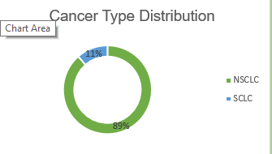
This shows that NSCLC represents the larger proportion of patients in the dataset.
- Overall Survival Rate
Out of the 2,000 patients:
- Survived: 756
- Did not survive: 1,244
- Overall survival rate: 38%
Figure 4
- Survival Rate by Cancer Stage
Cancer Stage | Survival Rate
Stage 1 | 70%
Stage 2 | 51%
Stage 3 | 17%
Stage 4 | 5%
Figure 5
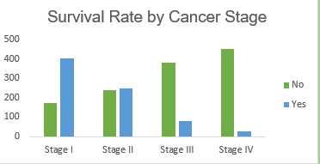
The analysis shows a substantial decrease in observed survival rate across the cancer stages in this dataset.
- Survival Rate by Smoking Status
Smoking Status | Survival Rate
Current smoker | 27%
Former smoker | 33%
Never smoked | 42%
Figure 6
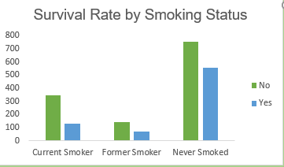
Never-smokers had the highest observed survival rate, while Current smokers had the lowest.
- Survival Rate by Gender
Gender | Survival Rate
Female | 42%
Male | 35%
Figure 7
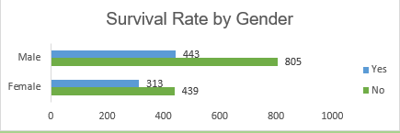
Female patients had a higher observed survival rate than male patients in this dataset.
- Patients by Diagnosis Year
Figure 8
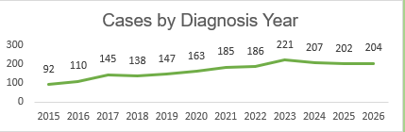
The line chart shows the number of recorded patients from 2015 to 2026. The highest number of patients recorded in a single year was 221 in 2023.

7. Dashboard Development
An interactive Excel dashboard was developed to present the key findings from the analysis in a clear and user-friendly format. The dashboard was designed to allow users to quickly understand the main patterns in the dataset without having to examine the raw data. This follows the capstone requirement for relevant KPIs, appropriate visualizations, clear labels, professional organization, and interactive elements.

7.1 KPI Cards
Two KPI cards were included:
- Total Patients: 2,000
- Overall Survival Rate: 38%
These provide a quick summary of the most important metrics.

7.2 Dashboard Visualizations
The following visuals were included:
- Cancer Type Distribution
- Survival Rate by Cancer Stage
- Survival Rate by Smoking Status
- Survival Rate by Gender
- Patients by Diagnosis Year
Figure 9
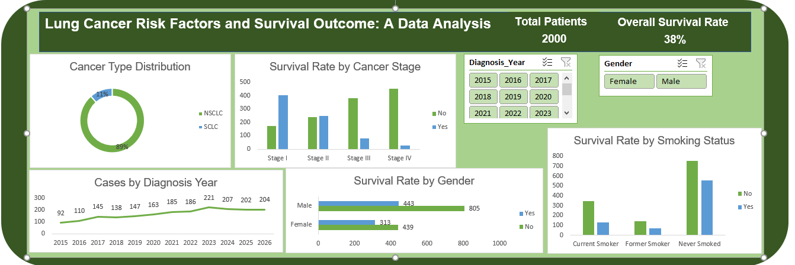

7.3 Interactive Slicers
Two slicers were included to make the dashboard interactive:
- Diagnosis Year
- Gender
Figure 10

These allow users to filter the dashboard and explore the data from different perspectives.

8. Key Findings / Insights
Based on the analysis of the cleaned dataset, the following key findings were identified:

8.1 Cancer Type
NSCLC was the dominant cancer type, accounting for 1,771 patients (89%), while SCLC accounted for 229 patients (11%).

8.2 Overall Survival
The dataset recorded an overall survival rate of 38%, with 756 patients surviving and 1,244 patients not surviving.

8.3 Cancer Stage and Survival
A strong pattern was observed between cancer stage and survival rate:
- Stage 1: 70%
- Stage 2: 51%
- Stage 3: 17%
- Stage 4: 5%
The observed survival rate decreased substantially as cancer stage increased.

8.4 Smoking Status and Survival
Survival rates differed across smoking categories:
- Never smoked: 42%
- Former smoker: 32%
- Current smoker: 27%
The never-smoked group had the highest observed survival rate, while current smokers had the lowest.

8.5 Gender and Survival
Female patients recorded an observed survival rate of 42%, compared with 35% among male patients.

8.6 Diagnosis-Year Trend
The number of patients represented in the dataset varied across 2015–2026, with the highest number recorded in 2023 (221 patients).

9. Recommendations
Based on my findings from the analysis, the following recommendations are proposed:
- Promote early diagnosis: The much higher survival rate observed at earlier stages highlights the importance of early detection and timely diagnosis.
- Strengthen smoking awareness: The lower observed survival rate among current smokers supports the need for smoking-cessation education and awareness programs.
- Encourage regular health screening: Regular screening and health checks may help identify potential cases earlier and support timely medical attention.
- Use data-driven monitoring: Healthcare organizations can use patient data to monitor survival patterns across cancer stages and risk-factor groups and support better decision-making.
- Continue monitoring trends: Diagnosis-year trends should be monitored over time to identify changes in the number of recorded cases and support future planning.

10. Conclusion
- The project successfully transformed 2,000 lung cancer patient records into meaningful insights using Microsoft Excel.
- The analysis identified important patterns in cancer type, survival, cancer stage, smoking status, gender, and diagnosis year.
- The findings showed a clear decrease in observed survival rates across later cancer stages.
- An interactive Excel dashboard was developed to present the key findings clearly and support data exploration.

Overall, the project demonstrates how data cleaning, analysis, visualization, and interpretation can be used to turn raw healthcare data into meaningful insights.

